Panel Reference. | PPSSTH-20
DA Number | 0563/2019
Local Government Area | Shellharbour City Council
Proposed Development | Redevelopment Of Site As An Eco-Tourist Facility Comprising 33 Guest Rooms, A Gym And Spa Area, Restaurant, Lounge Bar, Terrace and Pool Area
Street Address | 71 Fig Hill Lane Dunmore NSW 2529, Lot 3 DP 717776,
Applicant / Owner | Applicant: Mr G Cirillo  Owner: Alotap Pty & Ltd & David Moodie Pty Limited.
Date of DA Lodgement | 16 October 2019
Total number of submissions | 41 submissions were received in total.
Regional Development Criteria Schedule 7 of the SEPP (State and Regional Development) 2011 | Clause 6 Eco-tourist facilities over $5 million.  The proposed development has a CIV of $15,834.121.
List of all relevant s4.15(1)(a) matters | - Environmental Planning and Assessment Act 1979;  - State Environmental Planning Policy– Coastal Management 2018;  - State Environmental Planning Policy (State and Regional Development) 2011;  - State Environmental Planning Policy (Infrastructure) 2007;  - State Environmental Planning Policy– Remediation of Land;  - Shellharbour Local Environmental Plan 2013;  - Shellharbour Development Control Plan 2013;  - Environmental Planning and Assessment Regulation 2000;  - The likely impacts of the development, including environmental impacts on the natural and built environment and social and economic impacts in the locality;  - The suitability of the site for the development;  - Any submissions made in accordance with the EPA Act or EPA Regulation; and  - The public interest.
List all documents submitted with this report for the Panel’s consideration | Attachments  - Notice of Deferral  - Legal Review (CONFIDENTIAL)  - Rural Fire Service Advice  - BDAR response letter  - Plan demonstrating trees Proposed for retention and removal outside of APZ area  - Endeavour Energy Advice  - Riverside Drive/Fig Hill Lane intersection detail  - Draft Conditions
Clause 4.6 requests | Nil
Summary of key submissions | Refer to Assessment Report
Report prepared by

 | Jessica Saunders, Principal Planner
Date of report | 19 July 2021

supplementary report
puRPOSE OF REPORT
This report has been prepared to address the reasons for deferral as outlined within the Record of Deferral prepared by the Southern Regional Planning Panel dated 20 April 2021, following the Public meeting held by teleconference on the 13 April 2021. A copy of the Record of Deferral is provided at Attachment 1 to this Report.
This report provides a response to the reasons for deferral and information requested as outlined at points 1-7 (inclusive) of that notice.
Further commentary on additional submissions received and representation from the Applicant following the meeting is also provided.
The report concludes that the matters identified within the deferral notice dated 20 April 2021 have been addressed and all outstanding matters resolved.
As such, it is recommended that the application be determined by way of Deferred Commencement, subject to the draft conditions provided at Attachment x to this Report.

REASONS FOR DEFERRAL

The Panel agreed to defer the determination of the matter on the 13 April 2021 for the following reasons:

- Council’s assessment report and recommendations were revised prior to the meeting following receipt of correspondence from the Rural Fire Service (RFS) and the issue of General Terms of Approval (GTA). This information, while posted on the Panel’s website, has not been available for a sufficient period of time to enable procedural fairness.
- Legal advice from Esplins Solicitors provided by the Applicant (dated 6 April 2021) in connection with the terms of the Right of Carriageway benefiting the site has not been the subject of legal review and advice to the Panel by Council;
- A number of matters were raised in the public meeting and by Panel members that require further information or clarification prior to a determination.

The notice requested that the following information be submitted:

- A legal review of the advice provided by Esplins Solicitors submitted by the Applicant (dated 6 April 2021) in connection with the terms of the Right of Carriageway benefiting the site, and advice from Council in this regard. In particular the advice should address the proposed change and intensification of the land use on the DA site and the need or otherwise of landowners’ consent for the proposed road upgrade within the Right of Carriageway;

- Clarification on the following with regard to the proposed road upgrade works within the Right of Carriageway connecting the site to Riverside Drive:
  - the timing and responsibility for undertaking upgrade of the road within the section of the Right of Carriageway also subject to the Dunmore Lakes Sand Extraction Project (DA 195-8-2004 MOD 2);
  - any required tree removal; and
  - required width and standard of road surface to ensure suitable access for RFS vehicles;

- Clarification that the advice received from the Rural Fire Service, dated 1 April 2021 is complete and satisfies the requirements for a Bush Fire Safety Authority under Section 100B of the Rural Fires Act 1997 to be issued subject to the General Terms of Approval being met;

- Clarification that the proposed clearing of vegetation on the site, as a result of the revisions to the Asset Protection Zones (APZ) required in the RFS GTAs, remains below the threshold for offset requirements under the Biodiversity Conservation Act 2016;

- Clarification as to which trees are proposed to be retained and removed outside of the APZ areas of the site;

- Advice regarding the proposed upgrade of the Endeavour Energy electricity infrastructure to the site and the network capacity and timing of such works;

- A revised assessment report and recommended conditions of consent to incorporate the above information requirements and assessment of the proposed roadworks at the intersection of Riverside Drive and Fig Hill Lane. Should the revised assessment report recommend approval, the report is required to address why the reasons for refusal articulated in the original assessment report no longer apply.

A response to each of the reasons for deferral and information requests is provided below.

- Council’s assessment report and recommendations were revised prior to the meeting following receipt of correspondence from the Rural Fire Service (RFS) and the issue of General Terms of Approval (GTA). This information, while posted on the Panel’s website, has not been available for a sufficient period of time to enable procedural fairness.

Comment:
Councils Assessment Report, Memo relating to late information received and this supplementary report will be provided for a sufficient period of time prior to the scheduled public meeting of the 3 August 2021.

- Legal advice from Esplins Solicitors provided by the Applicant (dated 6 April 2021) in connection with the terms of the Right of Carriageway benefiting the site has not been the subject of legal review and advice to the Panel by Council;

Comment:
The Legal advice from Esplins Solicitors provided by the Applicant dated 6 April 2021 has been reviewed. See response to item 1 below.

- A number of matters were raised in the public meeting and by Panel members that require further information or clarification prior to a determination.

Comment:
These matters are outlined below.

- A legal review of the advice provided by Esplins Solicitors submitted by the Applicant (dated 6 April 2021) in connection with the terms of the Right of Carriageway benefiting the site, and advice from Council in this regard. In particular the advice should address the proposed change and intensification of the land use on the DA site and the need or otherwise of landowners’ consent for the proposed road upgrade within the Right of Carriageway;

Comment:

A summary on the Rights of Carriageway the subject of these comments is provided within the original assessment report.

A legal review of the advice provided by Esplins Solicitors relating to the Right of Carriageway, change and intensification of use and the need for landowners’ consent for road upgrade works within the Right of Carriageway has been undertaken and provided confidentially to the Panel as Attachment 2 to this report.

As a result of this advice, an additional condition of consent is recommended which requires all necessary consents and/or other approvals to be obtained for works on Lot 501 DP 1174897 and Lot 51 DP 1012246 prior to commencement of any works associated with the development the subject of this application and for any required works on Lot 501 DP 1174897 and Lot 51 DP 1012246 to be carried out prior to the issue of any Occupation Certificate for the development.

The advice provided indicates that the terms of the Right of Carriageway may allow for the intensification of use and for the carrying out of the upgrade works. The DA as presented does not relate to the land burdened by the ROC as the application does not itself propose or seek consent for works or intensification of use.

Should any required works within the ROC not fall within the exempt development provisions, a separate development application would be required. Should the owners of the burdened Lots not consent to the making of that application, it would be open to the owner of the Lot benefitted by the ROC to seek court orders requiring the owners of the Lots burdened by the ROC to give owners consent.

The additional condition recommended is provided below and has been inserted at condition number 8:

All necessary development consents and/or other approvals for works on Lot 501 DP 1174897 and/or Lot 51 DP 1012246 are to be obtained prior to the commencement of works associated with the development subject of this consent. Any works required on Lot 501 DP 1174897 and/or Lot 51 DP 1012246 are to be carried out and completed to the satisfaction of the Principal Certifier, prior to the issue of any Occupation Certificate of the development.

A further additional condition has been recommended and has been inserted at condition 61 to ensure that any works to Fig Hill Lane to ensure that the access to the site from Riverside Drive complies with the General Terms of Approval provided with the 100B Authorisation from the Rural Fire Service, any relevant Australian Standard and Austroad requirement are to be carried out and completed to the satisfaction of the Principal Certifier, prior to the issue of any Occupation Certificate of the development.

- Clarification on the following with regard to the proposed road upgrade works within the Right of Carriageway connecting the site to Riverside Drive:

  - the timing and responsibility for undertaking upgrade of the road within the section of the Right of Carriageway also subject to the Dunmore Lakes Sand Extraction Project (DA 195-8-2004 MOD 2);

Comment:

The Dunmore Lakes Sand Extraction Project (DA 195-8-2004 MOD 2) was conditionally approved by the Independent Planning Commission (IPC) on the 16 November 2020. The approval relates to the establishment of two new extraction areas (Stage 5 [comprising two parts, 5A and 5B]); the extraction of sand by excavator and dredging; the construct of a pipeline between Stage 5 and Stage 2; the pumping of the extracted sand from Stage 5 to the Stage 2 processing area; the pumping of processed water from Stage 2 to Stage 5; partial backfilling of the Stage 5 ponds with VENM and site rehabilitation. The Stages in context with the surrounding road network and property boundaries is demonstrated by Figure 1 below.
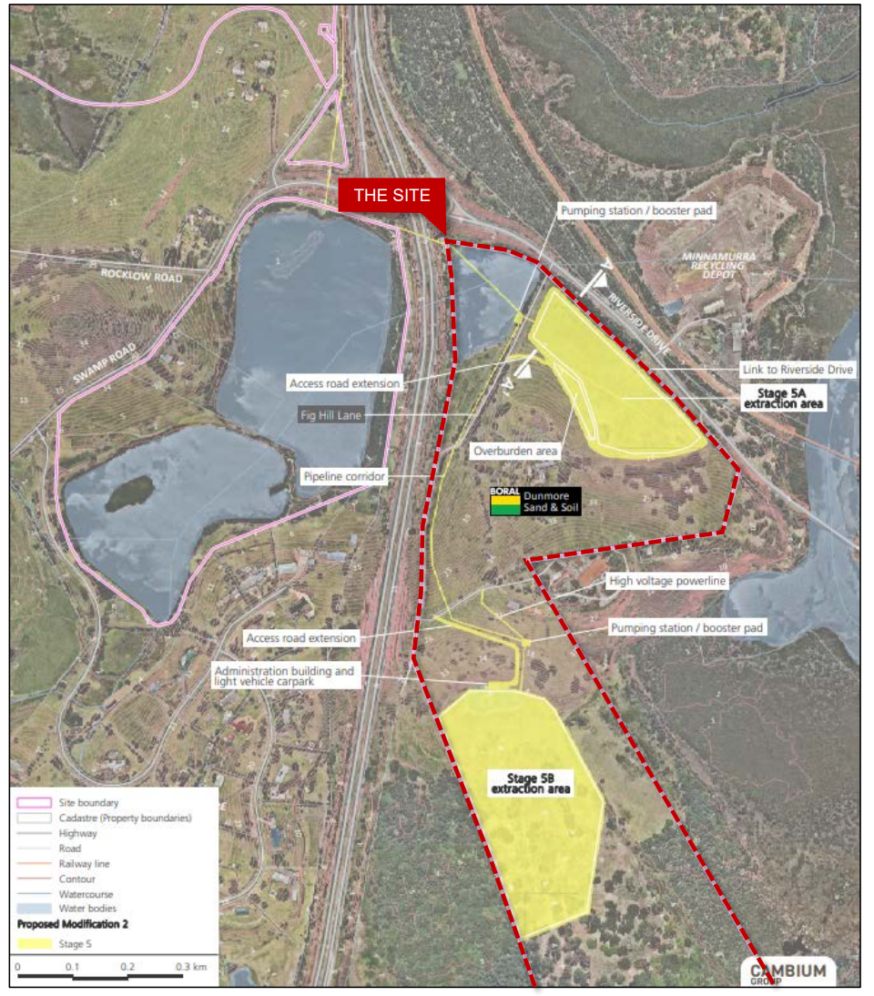
Figure 1: Dunmore Lakes Sand Extraction Project (DA 195-8-2004 MOD 2) Stage 5 internal access roads and indicative excavation areas displayed in yellow.

To provide access to the new extraction areas, a new access road from Riverside Drive is proposed. See Figures 2 and 3 below.
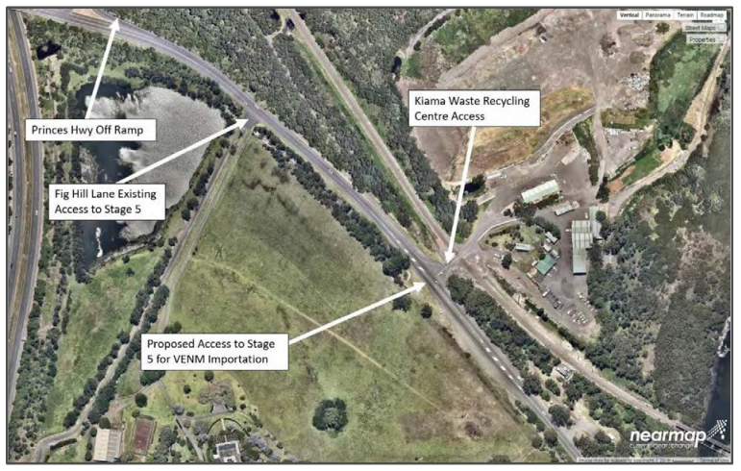
Figure 2: Riverside Drive location of proposed access to Stage 5 approved as part of the Dunmore Lakes Sand Extraction Project (DA 195-8-2004 MOD 2)
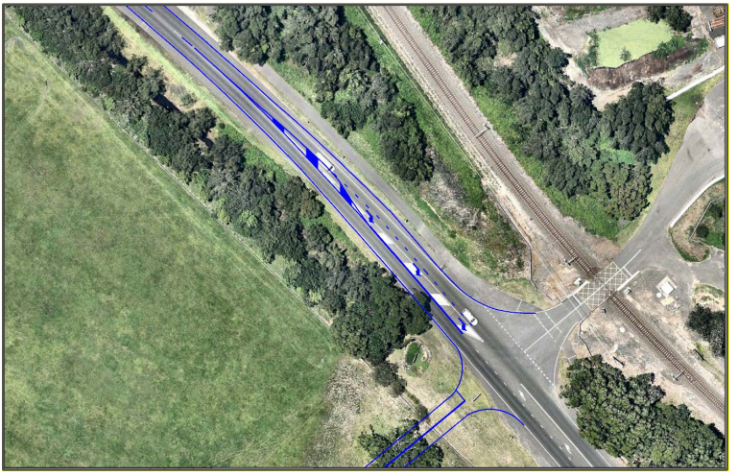
Figure 3: Detail of the Riverside Drive Stage 5 Area access

The new road would only be used by light vehicles accessing a new portable site office and car park, which would be located north of Stage 5B, and heavy vehicles delivering VENM to the extraction area during flood bund construction, access road construction and for rehabilitation.

Sand extracted from the site is proposed to be piped to the existing processing facility within the Stage 2 area of the Boral operations. The pathway of the pipeline is highlighted in blue at Figure 4 below.

The assessment report for the modification states that the “pipes would be laid and secured to the ground and travel from Stage 5B along the internal access road easement, beneath the Dunmore House access road and Fig Hill Lane to the Stage 5A extraction area, before heading north-west across the Stage 1 pond east of the Princes Highway and under existing culverts beneath the Princes Highway and Swamp Road to the existing processing facility”.

The Environmental Impact Statement addresses the access roads as per the following:

“The Stage 5 extraction areas are accessed via Fig Hill Lane. This access route is unsafe for haul vehicles as it is too close to the Princes Highway/Riverside Drive intersection. Therefore, a new access road will be constructed to the Stage 5 extraction area from Riverside Drive, opposite Saltwater Creek Road.

The access road will join a 3.5 m wide unsealed road around the perimeter of the Stage 5A extraction area, which will then join the existing Fig Hill Lane, a sealed road that heads southwards towards the Stage 5B extraction area. A new 240 m long and 3.5 m wide unsealed access track will need to be constructed down the slope from the end of Fig Hill Lane to the northern end of the Stage 5B extraction area and will require cut and fill earthworks.

A 3.5 m wide unsealed road will also be constructed around the perimeter of the Stage 5B extraction area to enable maintenance vehicle access.

All existing access arrangements for residents along Fig Hill Lane and Riverside Drive will be maintained during the Stage 5 operations.”

These arrangements are demonstrated at Figure 4 below.
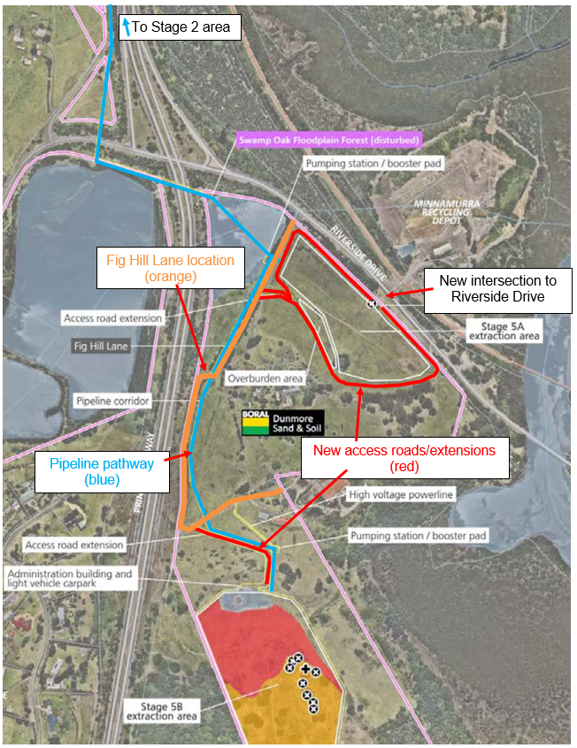
Figure 4: Access Roads/extensions (locations shown in red – surrounding Stage 5A extraction area and connecting to Fig Hill Lane approximately 140m from the Fig Hill Lane/Riverside Drive intersection, then connecting Fig Hill Lane from the left hand bend in the south to the 5B extraction area) and pipeline pathway (blue) approved as part of Dunmore Lakes Sand Extraction Project (DA 195-8-2004 MOD 2) and Fig Hill Lane locations.

As part of the modification, there is no proposal to or conditions which would require any upgrade works to Fig Hill Lane. The Environmental Impact Statement states that no widening of Fig Hill Lane is required to facilitate the heavy vehicle assesse to the Stage 5B extraction area.

  - any required tree removal; and

Comment:

As outlined above, no widening works are required along Fig Hill Lane to provide for the Dunmore Lakes Sand Extraction Project (DA 195-8-2004 MOD 2)

  - required width and standard of road surface to ensure suitable access for RFS vehicles;

Comment:

As discussed in the response to point 1 above, the DA as presented does not relate to the land burdened by the Right Of Carriageway as the application does not itself propose or seek consent for works or intensification of use. Should any required works within the ROC not fall within the exempt development provisions, a separate development application would be required

Notwithstanding, Condition 6 provided within the NSW RFS 100B authorisation for the project requires that access comply with Table 6.8b of Planning for Bush Fire Protection 2019, with the exception of secondary access.

Table 6.8b is provided at Figure 5 and 6 below.
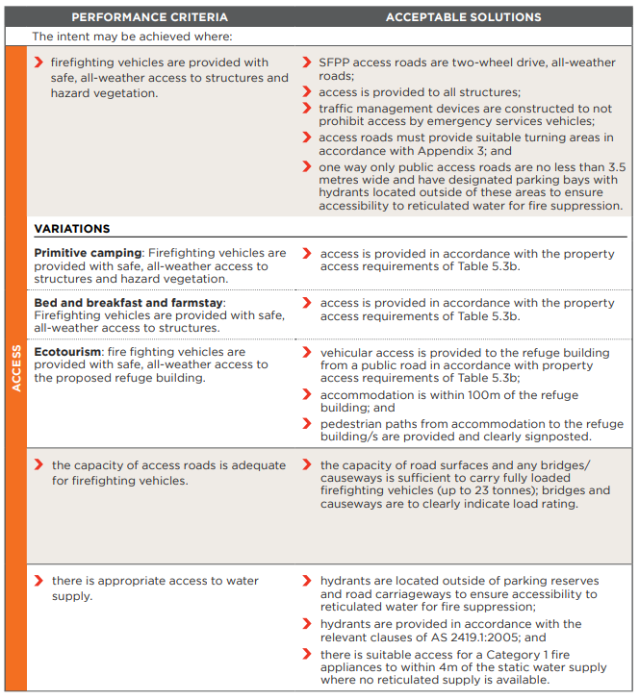
Figure 5: Table 6.8b extracted from Planning for Bushfire Protection 2019
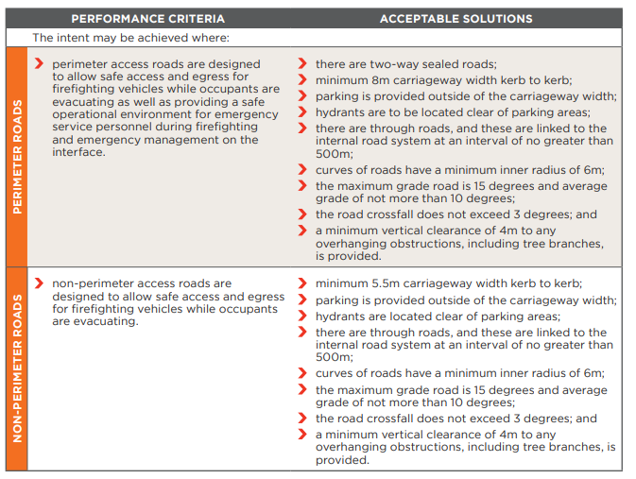
Figure 6: Table 6.8b extracted from Planning for Bushfire Protection 2019 (continued)

Pursuant to the variation permitted for Ecotourism developments, extracted below, vehicular access to be provided to the refuge building from a public road in accordance with the property access requirements of Table 5.3b.

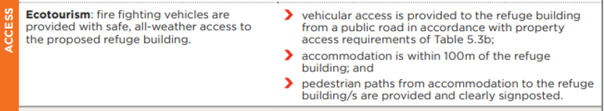
Figure 7: Table 6.8b Ecotourism part extracted from Planning for Bushfire Protection 2019

Table 5.3b provides different access requirements for three different access scenarios, being Perimeter Roads, Non-Perimeter Roads and Property Access Roads. Section 3.4 of Planning for Bushfire Protection 2019 defines the various access types referred to throughout the document. See Figure 8 below.
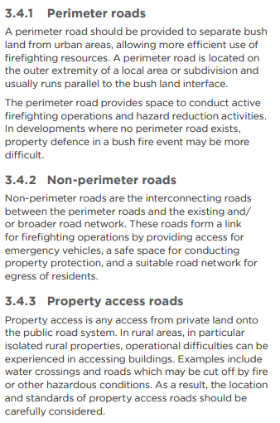
Figure 8: Access arrangements extracted from Planning for Bushfire Protection 2019

In the case of the subject site, Fig Hill Lane, as it is comprised of Rights of Carriageway, may be considered as a Property access road. This would be at the discretion of the Principal Certifier.

Table 5.3b provides General Requirements and detailed requirements for the different categories of access. The General Requirements and requirements for Property Access roads are provided as per Figures 9 and 10 below.
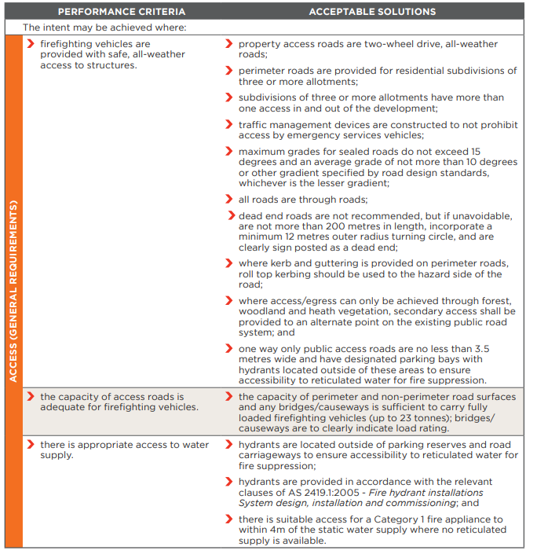
Figure 9: Access (General Requirements) within Table 5.3b extracted from Planning for Bushfire Protection 2019.

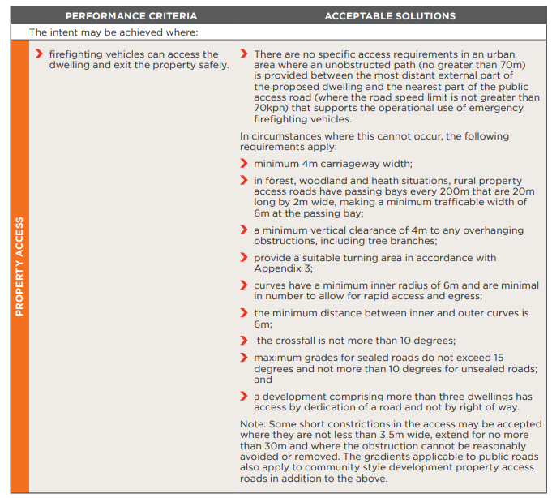
Figure 10: Property Access requirements within Table 5.3b extracted from Planning for Bushfire Protection 2019.

A minimum 4m carriageway width would be required if the Principal Certifier was to accept that Fig Hill Lane was a property access road.

As discussed under point 1 above, conditions are recommended to ensure that the access to the property complies with any relevant Australian Standard and Austroads requirement and the conditions on the 100B authorisation issued by the NSW RFS.

As works within the Right of Carriageway areas do not form part of the subject application, should satisfying this condition require additional approvals, (see also recommended condition 8), a further development application/s will be required.

- Clarification that the advice received from the Rural Fire Service, dated 1 April 2021 is complete and satisfies the requirements for a Bush Fire Safety Authority under Section 100B of the Rural Fires Act 1997 to be issued subject to the General Terms of Approval being met;

Comment:

See Attachment 3 to this report. The NSW RFS have confirmed that the advice received dated 1 April 2021 satisfies the requirements for a Bushfire Safety Authority, despite the ‘certificate’ not generating.

- Clarification that the proposed clearing of vegetation on the site, as a result of the revisions to the Asset Protection Zones (APZ) required in the RFS GTAs, remains below the threshold for offset requirements under the Biodiversity Conservation Act 2016;

Comment:

The outer extent of the Asset Protection Zone has not changed as a result of the RFS GTAs. The applicants ecological consultant has verified that the clearing for the Asset Protection Zone is consistent with the BDAR. See Attachment 4 to this report

As a result of the revisions to the APZ requirements as provided within the GTAs, the location of the Clifftop Units 1 building is to be relocated 1m to the north west. This is accounted for at Condition 9(i) provided at Attachment 8.

- Clarification as to which trees are proposed to be retained and removed outside of the APZ areas of the site;

Comment:

See Attachment 5 to this report which identifies the trees proposed to be retained and removed outside of the APZ areas of the site.

- Advice regarding the proposed upgrade of the Endeavour Energy electricity infrastructure to the site and the network capacity and timing of such works;

Comment:

The Applicant has provided information from Endeavour Energy, provided at Attachment 6 to this report. This information provided a desktop assessment of the load requirements of the development and concluded that the requested load of 280Amps/Phase would not be able to be supplied from the existing pole Sub 40895 near the development (located within Lot 501 DP 1174897, 471 Riverside Drive, Dunmore). The assessment concluded that the requested load will be supplied from an existing feeder in Shellharbour, with a new sub on site required to supply the requested load. There is sufficient room on the site for the installation of a padmount substation.

The timing of the works would be dependent on the application and would be required to be carried out concurrently with the construction works. An additional draft condition has been included at condition 67 which requires that a suitable power supply be provided to the site and any associated padmount substation and easements relating to that substation be installed and registered on the title of the land, prior to the issue of any Occupation Certificate.

- A revised assessment report and recommended conditions of consent to incorporate the above information requirements and assessment of the proposed roadworks at the intersection of Riverside Drive and Fig Hill Lane. Should the revised assessment report recommend approval, the report is required to address why the reasons for refusal articulated in the original assessment report no longer apply.

Comment:

It has been confirmed that the subject supplementary report will be sufficient to address this matter.

With regard to the works at the intersection of Riverside Drive and Fig Hill Lane, please see Attachment 7 which provides details of these works and demonstrates that they are able to be undertaken within the existing road reserve area and without any vegetation removal. Several conditions including numbers 17, 37 and 50 have been recommended to ensure that the works are designed and carried out appropriately, and completed prior to the issue of any Occupation Certificate.
.
The draft reasons for refusal as presented in Councils report of the 25 March 2021 were primarily in relation to a 100B authorisation from the NSW Rural Fire Service not having been provided at the time of preparing the report, and the uncertainty in what any requirements of a 100B authorisation may have on the recommended Asset Protection Zones, vegetation removal and access requirements. As these matters have now been resolved, the draft reasons for refusal no longer apply.

This report recommends that the application be determined by way of deferred commencement, subject to the conditions provided at Attachment 8.

ADDITIONAL SUBMISSIONS RECEIVED

Following the public meeting on the 13 April 2021, Council has received a further xx submissions from adjoining property owners and the applicant. The issues identified are discussed below.

Please note that a full analysis of the submissions received across the two formal exhibition periods is provided at Attachment 6 to the SRPP Assessment Report dated 25 March 2021.

Concern | Comment
Access  Concerns have been raised with regard to the ability of the access to the site to comply with Rural Fire Service requirements including Planning for Bushfire Protection and the ability for the use of and works on land within the Right of Carriageway area.  A survey has been undertaken and provided to Council which confirms that the width of the existing pavement of Fig Hill Lane varies from around 3 to 4 metres.  Concern has also been raised with regard to the use of the Right of Carriageway sterilising the use of the land for other purposes and liability for people using Fig Hill Lane to access the site. | See discussion above with regard to access and RFS requirements. The subject DA as presented does not relate to the land burdened by the Right Of Carriageway as the application does not itself propose or seek consent for works or intensification of use.  Council sought advice with regard to the access and that advice indicates that the terms of the Right of Carriageway may allow for the intensification of use and for the carrying out of the upgrade works. However, this is a matter separate to the subject application.  Additional conditions 8 and 61 have been imposed to ensure that if works to satisfy Rural Fire Service, Australian Standard or Austroads requirements not fall within the exempt development provisions; that any required development consent is obtained prior to the commencement of any work and the work completed prior to the issue of any Occupation Certificate.
Car Parking  Concern has been raised as to whether the car parking proposed on site would be sufficient given the bar, restaurant and other services will be open to the public and the submitted BCA report stated that the resort could hold up to 625 people. | Council’s Engineering Department have assessed the car parking numbers and configuration and raised no objection to the design subject to the imposition of conditions.
Use of the site as an ‘eco-tourist facility’  It is unclear how the proposal didn’t meet the requirements to be considered an ‘eco-tourist facility’ in Councils original assessment report, but then was considered suitable in the second. What happened to make it change? | The original assessment report considered the proposal against the relevant provisions of the Shellharbour Local Environmental Plan 2013 for eco-tourist facilities. That report concluded that ‘subject to the establishment of the Biodiversity Stewardship Agreement and imposition of appropriate conditions, the development would have been capable of satisfying the provisions of Clause 5.13 SLEP 2013. However, as the matters relating to NSW Rural Fire Service requirements remains unresolved at the time of preparing this report, it is unclear what the impacts of resolving the outstand matters may be.’  As outlined within the addendum note dated 9 April 2021, the NSW Rural Fire Service provided a 100B authorisation for the development which included conditions which didn’t affect the extent of vegetation removal required. Subsequently, subject to conditions, the proposal is considered to satisfy the provisions relating to eco-tourist facilities.
Effluent drainage  Concern has been raised as to the effluent drainage area proposed and the location of the area with regard to surrounding sensitive areas. | The design of the on site effluent disposal system has been reviewed by Councils Health Officer and is considered appropriate subject to conditions. The conditions require regular monitoring and maintenance to ensure that there are no impacts to surrounding land.
Amenity Impacts  Concerns have been raised as to the impacts of noise, loss of privacy, lighting and amenity on adjoining properties. | In response to noise generation concerns, the Applicant has prepared a Plan of Management (PoM) which includes measures to manage operational noise. In addition, conditions are recommended which require a monitoring period of 12 months to ensure the matters within the PoM and management of the operation minimises any potential noise and light impacts.  Subject to the imposition of the conditions, Council is satisfied that noise generation and illumination from the site would have resulted in minimal impacts on surrounding properties, flora and fauna.  Given the location of the site, surrounding topography, proposed levels and the orientation of higher use areas of the development, there are not expected to be any unreasonable amenity impacts to adjoining properties.
Contamination  Concerns have been identified with regard to previous filling of the site. | See discussion at SEPP 55 within the original assessment report. The land, including the land outside of the footprint of the current development proposal, was the subject of Class 4 proceedings in the Land and Environment Court in relation to unauthorised fill and clearing but the matter did not relate to the importation of contaminated material as defined under the Act. The potential contamination of the site has been considered and the site is considered suitable for the proposed land use.
Timing for the commencement of development works  Concern has been raised that the recommended conditions would result in works associated with the development not proceeding until the Biodiversity Stewardship Agreement (BSA) is finalised, which would result in the continued vandalism of the site and trespass of surrounding sites. Submissions also indicate that the requirement for the BSA to be a deferred matter is onerous and unnecessary. The submissions request that works including the demolition of the existing building be permitted to commence prior to the BSA being finalised and propose that the condition presented as a deferred commencement matter in the draft conditions attached to Councils report of 9 April 2021 be relocated to either to be satisfied within a certain timeframe following the granting of consent or prior to the issue of a Construction Certificate. | The BSA is being heavily relied on to satisfy the provisions of clause 5.13 of the Shellharbour Local Environmental Plan 2013, being matters that are required to be satisfied prior to the granting of consent for the development of an eco-tourist facility.  This, coupled with the understanding of the process that sits behind the BSA, which if not able to be satisfied results in the development being unable to satisfy enabling clause in the LEP, Council does not support the request to remove the BSA from being a deferred commencement matter.  Following this being relayed to the applicant, it was requested that the timeframe for satisfying the deferred commencement condition be extended to 5 years. This has been considered and the draft deferred commencement condition amended to provide 36 months for the matters to be satisfied. This is considered to be reasonable given all information available as to the likely timeframes surrounding the establishment and process to enter active management for a BSA site. Further, the timeframe could also be modified at a future date if further time was required.  With regard to the ability for demolition works to commence at the site in the interim, as the works form part of the subject application they would also not be able to commence until such time as the deferred commencement matter is resolved. However, a separate application for demolition works could be sought.

CONCLUSION

The proposed development has been assessed with regard to the relevant prescribed matters for consideration outlined in Section 4.15 of the Environmental Planning & Assessment Act 1979, the Biodiversity Conservation Act 2016, the provisions of the Shellharbour Local Environmental Plan 2013 and all relevant Council DCPs, Codes and Policies.
The proposed eco-tourist facility is with consent pursuant to the SLEP 2013. The proposal has satisfied the relevant provisions of Clause 5.13 of the SLEP 2013, subject to the recommended conditions provided at Attachment 8 to this report.
The development is consistent with the applicable provisions of the relevant planning instruments including SEPP (Coastal Management) 2018, SEPP (Infrastructure) 2007, SEPP 55, Shellharbour LEP 2013 and SDCP 2013.
All internal and external referrals are satisfactory and there are no outstanding issues.
It is considered that the proposed development is unlikely to result in adverse impacts on the character or amenity of the surrounding area, environment and adjoining development, subject to the recommended conditions.

RECOMMENDATION
DA0563/2019 be determined by way of Deferred Commencement pursuant to Section 4.16 of the Environmental Planning and Assessment Act 1979, subject to the conditions provided at Attachment 8.

ATTACHMENTS
1 | Notice of Deferral
2 | Legal Review (CONFIDENTIAL)
3 | Rural Fire Service Advice
4 | BDAR response letter
5 | Plan demonstrating trees Proposed for retention and removal outside of APZ area
6 | Endeavour Energy Advice
7 | Riverside Drive/Fig Hill Lane intersection detail
8 | Draft Conditions

